1) .idea

src

lab1.iml

2) java.base

java.rmi

java.se

3) 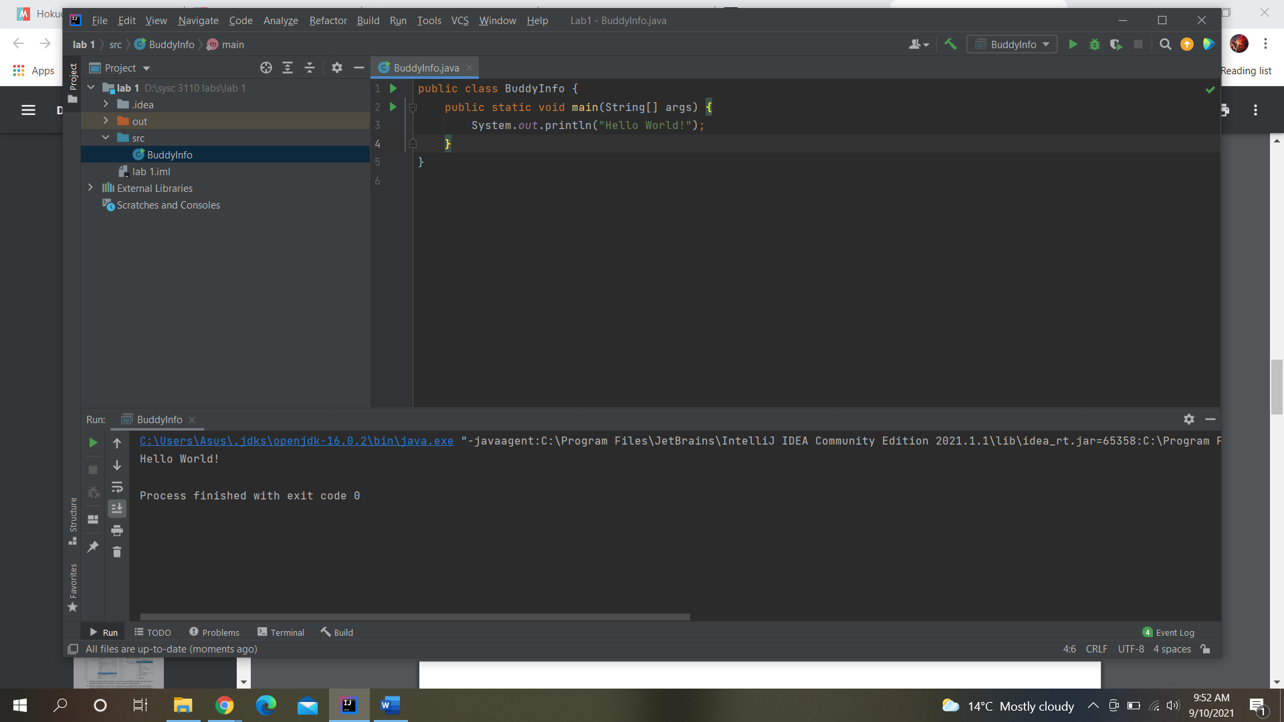

4) lab1 -> src -> BuddyInfo.java -> BuddyInfo.class

5) (JAR file in Brightspace)